14-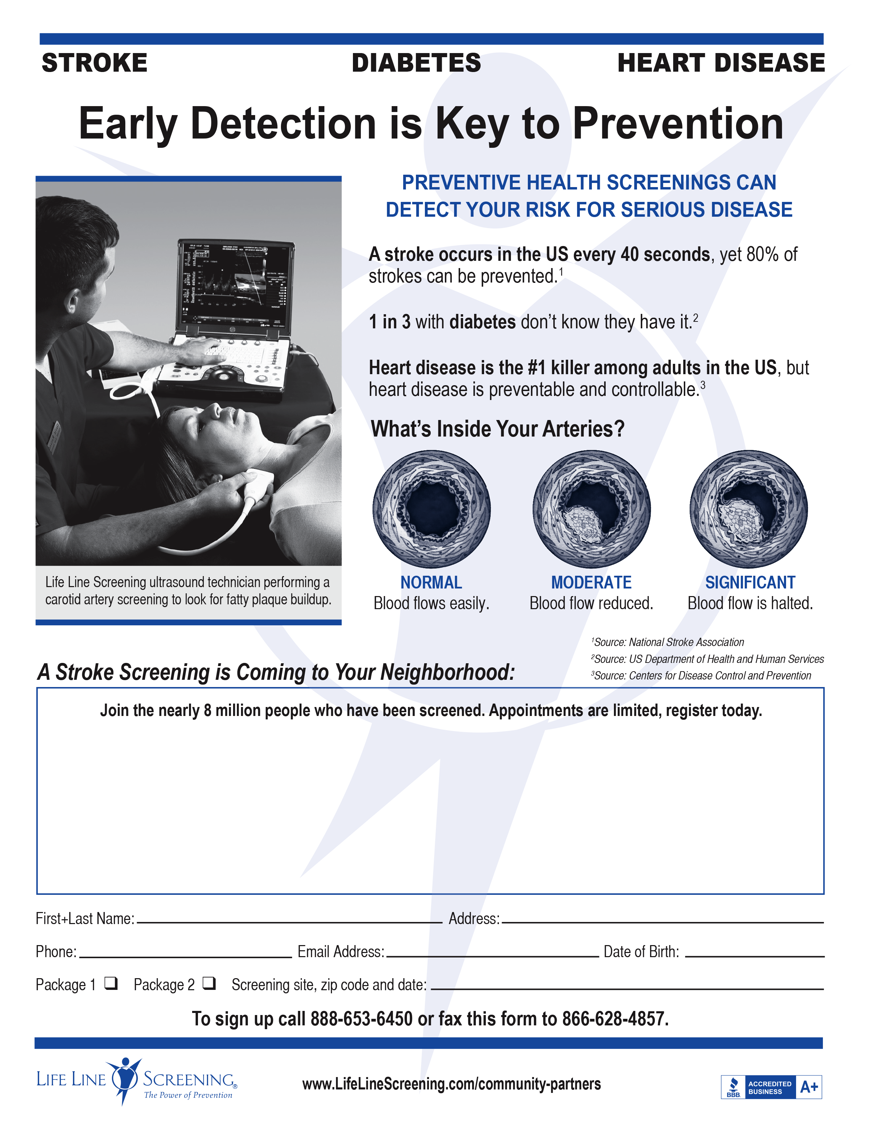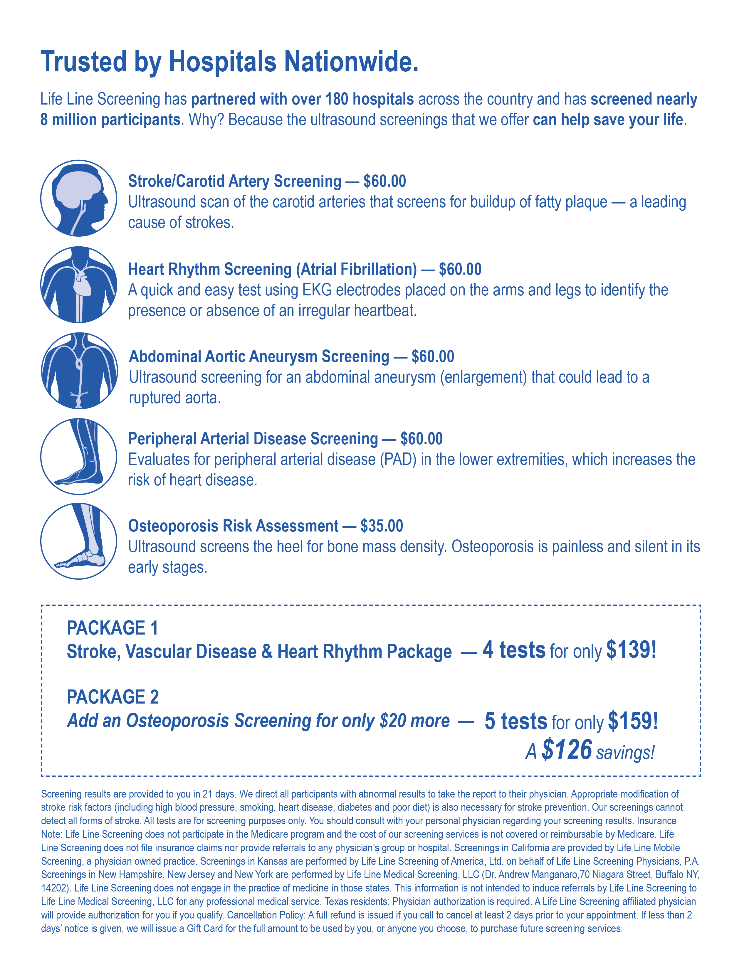

**Where: Zion Lutheran Church**

**When: February 22nd, 2018**

**To pre-register and to receive a $10 discount on one of our vascular packages, please call 1-888-653-6450**

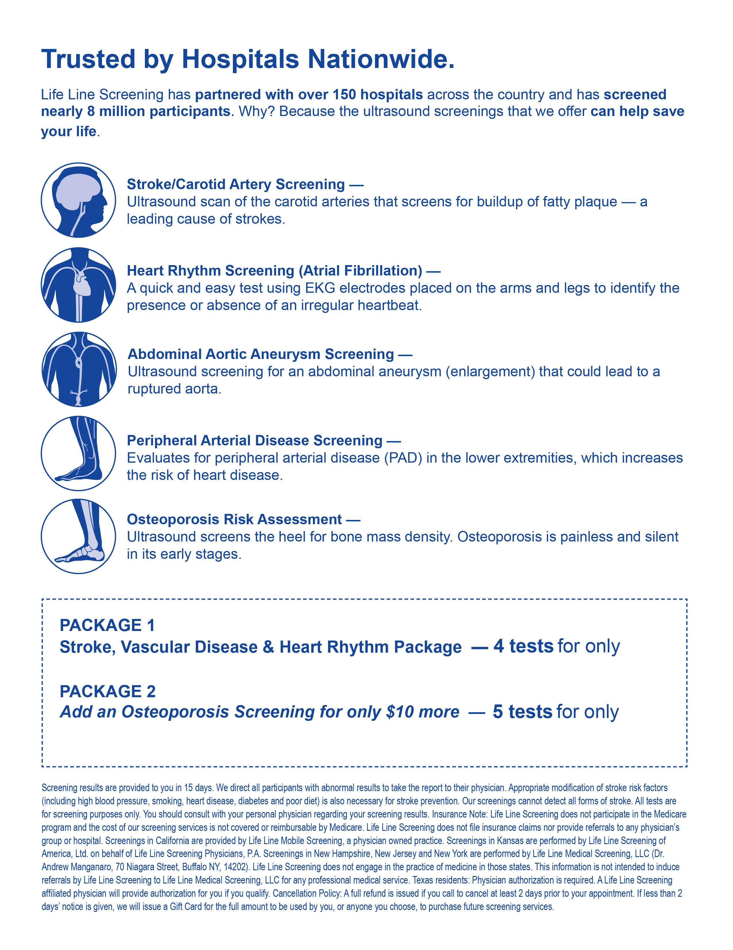

*A* ***$181*** *savings!*

**$149**

**$139**

**$70.00**

**$60.00**

**$60.00**

**$70.00**

**$70.00**